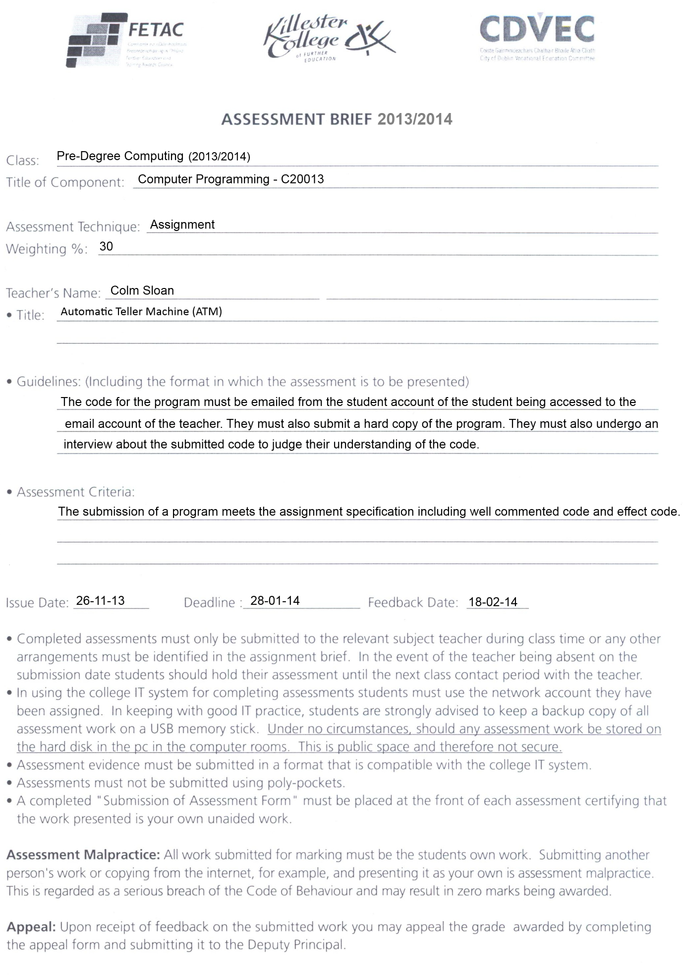

Computer Programming in Python – Assignment 1

**Deadline**: 28-01-14 – 7pm

**Marking Schedule**: 90 total marks

* Clearly documented program code – 15 marks
  + what the code does AND how it does it
  + in this case, let the comments be the documentation
  + at least one comment for each block of code, not necessarily every line
* Excellent screen layout – 15 marks
  + console output should be information, neat and readable
* Effective code layout – 15 marks
  + following the style guide (<http://google-styleguide.googlecode.com/svn/trunk/pyguide.html>)
  + e.g. proper indentation, spacing, brace placement etc.
* Accurate programming (syntactically and semantically) – 30 marks
  + marks for each step in the process that works
  + try to repeat code as little as possible
  + prefer simple solutions
  + minimizes processing and memory requirements
* Appropriate testing – 15 marks
  + Validate user input i.e. warn user for every possible mistaken input they can give

**Assignment**:

An Automated Teller Machine (ATM) is used to dispense cash to bank customers without the need to be served by a human employee. In this assignment, you must program a basic ATM. The user must first enter their Personal Identification Number (PIN). Entering the incorrect PIN three times causes the program to close after informing the user why they are being locked out. Enter the correct PIN allows the user to proceed. The user should be able to then select between a balance enquiry and cash withdrawal. Selection throughout the program is performed by the user entering a number where each option available has a corresponding number For example, the options may be “1. Balance Enquiry” and “2. Cash withdrawal”. Entering 1 causes the balance enquiry to be performed. Selecting the balance enquiry causes the balance of the user to be displayed. This ATM will assume there is only one user and that the details of the user, both their balance and PIN, are hard coded into the ATM. The user balance should start at $200. The user PIN should be 1234.

Selecting cash withdrawal causes a selection of eight different options to appear: 20, 50, 60, 90, 120, 150, 180, custom amount. Use dollars ($) as the denomination. The ATM itself has $250 of money available to dispense. The ATM should not be to dispense more than this. If the user attempts to withdraw an amount exceeding the amount available in either the user account balance or the amount available to dispense, an error should inform the user why that action is impossible. Upon successful withdrawing cash, display the current user account balance and the amount available to the ATM to dispense.

The program should contain an ASCII art drawing on the screen of the first menu. This art can be very simple but must be your own.

The user should always be informed of why an action failed. Ensure that the user selects only numbered options available. Ensure the user cannot enter no number and press Enter as no option would have been selected. Don’t worry about alphabetical input, negative numbers or other data validation.

**Submission**:

E-mail program code and hand in a printed copy of the code by the deadline. Each student will undergo an interview about their code to make sure they understand it. This interview will be recorded. This recording will be kept if the student is suspected of not being the sole author of the original work submitted for the assignment. Results will be received within three weeks of submission.